Process management:-

Note:-Any comamnd that ends with & by default it takes as bg(background process).

In linuc we have 5 digit process id which is 5 digit number i.e pid.

Process in linux are of two types:-

1)**Foreground process**:- It will work in the front.Any process will run is by default background process.Ituses shell I/O terminal.It can be processed one at a time P1🡪P2🡪P3.Any command given operates with the process.If I want process to be foreground we use command |> fg processid.

2)**Background process**:- It will not show in front in terms of working.’n’ processes can run.if they need input they wait and once input is given as output. If I want process to be background we use command |> bg processid.

Ps command:-

|-> ps -f

|-> ps $(ls)

If we want to use multiple command in one command then

|-> echo “$(ps) $(ls)

|->ctrl+c it is used to break any process in lnux.

|->top it will give u list of all type of processes i.e background,foreground,system processes in the linux system.

Expansion:-

When you typw a comand and use enter it takes action as per command.Before u take actions same internal things are taken i.e actions are taken i.e. expansion.

1)* 🡪Match any (one or more)

|->echo

|->echo *

|-> echo D*

|->echo *s

2)~ 🡪 It tend to give home directory.

|-> ~

3)$((expression)) 🡪Any works with the expression we will use with $.

|->2+3

|->echo 2+3

|->echo $((2+3))

4){ } 🡪 It is used for combining form.

a)list

|->echo {1..10}

|->echo {10..1}

|->echo {1,3..13}

Our task is to get the even and odd number printing.

|->echo {a..z}

|->echo {A..z}

b)Creation of sequences:-Pretext-{list}-Posttext

for eg:-Pretext-{A,b}-Posttext

Pretext-{A}-Posttext

Pretext-{B}-Posttext

|->echo amar-{1,2,3}-panchal

|->echo Image-{1,2,3,4,5}.jpg

5)$(command):-Command substitution.It will first execute the command first then it is converted into string and then actions is done.

6)” ”🡪It will print the content of the file.

‘ ’ 🡪It will print Raw text.

\ 🡪It is used to get the Raw string.The special operations are removed by this operator

Eg:-“cost is \$5”

File

File can be 🡪normal file

🡪directory

🡪special:-Specially for encryption,networking it creates block files.Character files for extracting the data.Pipe file used for streaming media.Symbolic link file which is given by google .i.e. hyperlink.For chatting socket file is given.for eg:-like whatsapp chatting.

To Know the type of file use command

|-> -option file

-b :-Block file

-c :-Character file

-s :- Socket file

-d :- Directory

-k :-bit (Binary format)

-p :-pipe

-g :-groupid bit

-f :-normal file

Ways to create a files:-

1)nano ____.__

2)touch file -type

Commands for copy and move and remove

Copy - cp

Move - mv

Remove - rm

What is directory?

Directory a symbolic file containing list of raw files.

When we load .exe file it will create multiple files internally

Temp 🡪images

🡪audio

🡪Text

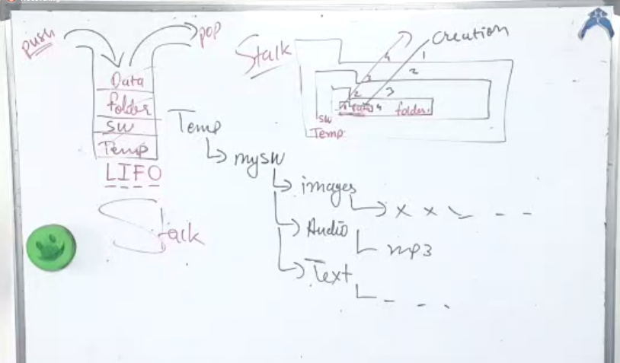

Linux supports stack system

It uses **pushd** command to push in and **popd** command to pop out.

It uses LIFO and whenever removing it removes las file which gets in as we can see in the figure.

Redirections:-

<

<<

>

>>

1st two are for input and last 2 are for output.

|-> ls > listdata

|-> nano listdata

|-> echo “iyla”

|-> echo “iyla” > listdata

|-> nano listdata

|-> echo < listdata

|-> ls > listdata

|-> echo “aiyla” > listdata

nano listdata

echo “sachin” >> “

In normal situation our data i.e. input goes in terminal and displays the output.

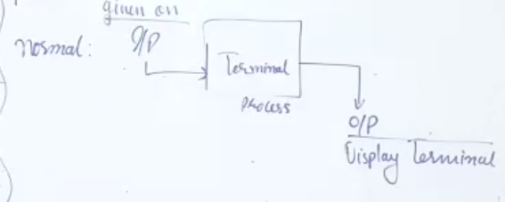

In redirections we have command which take input in the file given to terminal and gets ouput in the file.

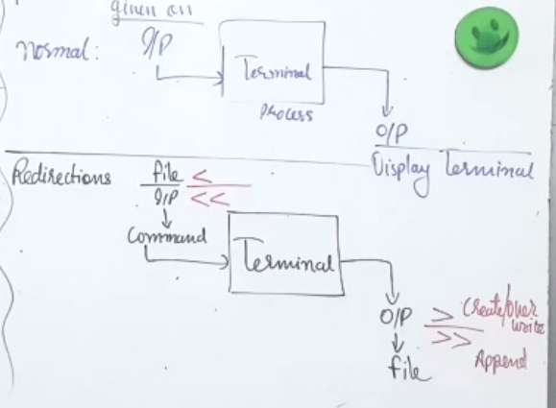

I/P operation:-

|->nano mydata.txt

|-> Data = $( < mydata.txt)

|-> Data

|-> $ $data

For file reading we need to install following

|-> sudo dnf install $(listpackage list)

Complete DISTRIBUTED SYSTEM

1)Software:Single coherent view.It will give you single global view.

2)Hardware:support to heterogenity.It means different hardwares.for eg:-google drive.

What are the 3 timestamps?

Date of last access.

Date of creation.

Date of modification.